|  |  |  |  |  |  |  |  |  |  |  |
| --- | --- | --- | --- | --- | --- | --- | --- | --- | --- | --- |
|  |  | | Daffodil International University | | | | |  |  | |
|  |  | | |  | | |  | |  | |
|  | | | | | | | | | | |
| http://4.bp.blogspot.com/-SotLIkzmscA/UqQLE9BjdPI/AAAAAAAAARc/-SF46qFfVE0/s1600/daffodil-international-university-logo.png | | | | | | | | | | |
|  | | | | | | | | | | |
| “**STUDENT PORTAL**"  **Course**: Software Engineering Project(ii) Web Programming | | | | | | | | | | |
|  | | NAME | | | **:** | Shabbir Ahmed Shakib | | | |  |
| ID | | | **:** | 142-35-664 | | | |
| DEPARTMENT | | | **:** | Software Engineering | | | |
| Faculty of Science and Information Technology | | | | | | | |
|  | | |  |  | | | |
| December 2017 | | | | | | | | | | |

Table of Contents

Chapter 1 1

1. Introduction 2

1.1 About the System 2

1.2 Purpose 2

1.3 Scope 2

1.4 Vision 2

1.5 Why this system is necessary? 2

1.6 Proposed Solution 2

Chapter 2 5

2. System Analysis 6

2.1 Use Case Model 5

2.2 Actor Goal List 5

2.2.1 Assumptions 5

2.3 Use Case Model 5

2.4 Use Case Description (Brief) 5

2.4.1 Register Accounts (Example) 5

2.5 Use Case Description (Detailed) 6

2.5.1 Register Account (Example) 6

2.6 System Sequence Diagrams 6

2.6.1 Register Account 6

2.7 Domain/Conceptual Model 7

2.8 Activity diagram 8

Chapter 3 15

3. System Design 10

3.1 Sequence Diagrams 10

3.1.1 Register Account 10

3.2 Class Diagram 11

3.3 Entity Relationship Diagram 13

Chapter 4 15

4. Implementation 15

4.1 Tools &Technologies 16

4.2 Project Link 16

Chapter 5 21

5. System Testing 22

5.1 Why Software Testing is Essential? 19

5.1.1 Black box testing 19

5.1.2 White box testing 19

5.2 Test Cases 19

Chapter 6 20

6. Conclusion 24

6.1 Good Features of the System 21

6.2 Limitations of the System 21

6.3 Future Enhancements 21

7. References 25

Chapter 1

Introduction

# Introduction

## About the System

## Education system forms the backbone of every nation. Hence it is important to provide a strong educational foundation to the young generation to ensure the development of open-minded global citizens securing the future for everyone. Advanced technology available today can play a crucial role in streamlining education-related processes to promote solidarity among students, teachers, parents and the school staff. So in my project I want to give a modern and advance technology to our students. In this application A student can see students information, search their results. A teacher can add student, add there marks. Admin can add teacher and student, and also can add result.

## Purpose

The main purpose of this project is to computerize the manual system & reduce the time consumption.

In other words, my project has the following purposes: -

* + Make all the system computerize,
  + Reduce time consumption,
  + Reduce error scope,
  + All system managements are automated,
  + Centralized database management,
  + Easy operations for operator of the system,
  + No paper work requirement.

## Scope

This system will be used by teachers and students of varsities. Teachers can login, register, add info and student can also login, register and see their info from anywhere.

## Vision

The main purpose of this project is to computerize the manual system & reduce the time consumption.

## Why this system is necessary?

This system is necessary to reduce time consumption, error scope, no paper work requirement and Centralized database management. So in this project I want to give a modern and advance technology to our students.

## Proposed Solution

The expected outcome of this system it will be a user friendly to interact with the user. The feature of this system is given below:

LOGIN & REGISTRATION FORM:

This form shows the Login name and password when user enter a

valid user name and password then he/she can operate the application.

STUDENT FORM:

This form provides the option to add, modify, delete or find the information of a student who seeks the admission in the school.

TEACHER FORM :

This forms provides the option to add, delete, search and delete the information of staff (either teaching or non-teaching) that is

working in the school.

RESULT FORM :

This form displays the options for the user to add, delete and modify the details of student related to the marks .

# 

Chapter 2

**System Analysis**

# System Analysis

## Actor Goal List

### Teachers

* Login to their account.
* Add, delete, search and delete the information of staff.

### Students

* Login to their account.
* Add, delete, search and delete the information of them.

## Use Case Model

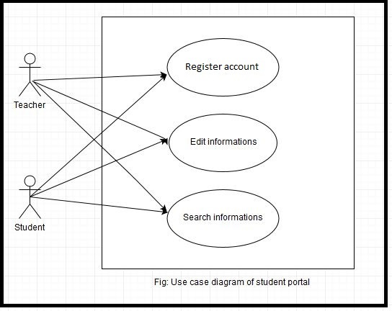

## Use Case Description (Brief)

### Register account:

This form shows the Login name and password when user enter a valid user name and password then he/she can operate the application.

### Edit informations:

This forms provides the option to add, delete, search and delete the information of staff (either teaching or non-teaching) that is

working in the school.

### Search informations:

Teacher and student can search information according to id number.

## Use Case Description (Detailed)

### Register accounts

|  |  |
| --- | --- |
| Use Case ID | 1 |
| Name | Register account |
| Primary Actor | Teacher |
| Secondary Actor | Student |
| Goal | Get. edit, delete the information |
| Precondition | Make registration |
| Post Condition | User name and password should be correct. |
| Main Success Scenario | 1. Teacher selects register option to register an account for user.  2. Teacher will enter the relevant data about user e.g. user basic information.  3. Teacher will enter the date for registration of user account.  4. Teacher will assign roles to the account that what a user do in the system respective to user designation.  5. Teacher submits the required description about user to the system.  6. System will save the record in the database and will show the success message. |
| Scenario Extensions | 1. When teacher tries to enter data for an already register user the system will generate an error message.  2. System will not register an account unless an teacher register the account. |

### Edit information

|  |  |
| --- | --- |
| Use Case ID | 2 |
| Name | Edit information |
| Primary Actor | Teacher |
| Secondary Actor | Students |
| Goal | Edit the information. |
| Precondition | Make registration and login to the system. |
| Post Condition | User name and password should be correct. |
| Main Success Scenario | 1. Teacher will enter the relevant data about user basic information.  2. Teacher submits the required description about user to the system.  3. System will save the record in the database and will show the success message. |
| Scenario Extensions | 1. When teacher tries to enter data for an already register user the system will generate an error message.  2. System will not register an account unless an teacher register the account. |

### Search information

|  |  |
| --- | --- |
| Use Case ID | 3 |
| Name | Search information |
| Primary Actor | Students |
| Secondary Actor | Teacher |
| Goal | Search required information |
| Precondition | Make registration and login to the system. |
| Post Condition | User name and password should be correct. |
| Main Success Scenario | 1. Students will enter the relevant data about user basic information.  2. Students submit the required description about user to the system.  3. System will show the recorded data from the database |
| Scenario Extensions | 1. When Student tries to enter data for an already register user the system will generate an error message.  2. System will not register an account unless a student registers the account. |

## System Sequence Diagrams

### Register account

**2.6.1.1 Success scenario**

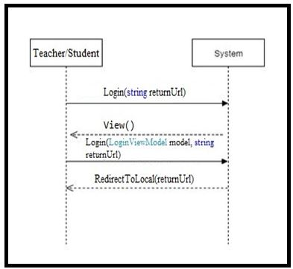

**2.6.1.2 Failure Scenario**

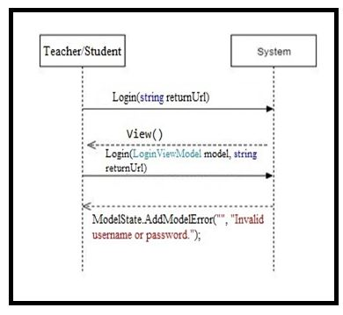

**2.6.2 Edit Information**

**2.6.2.1 Success scenario**

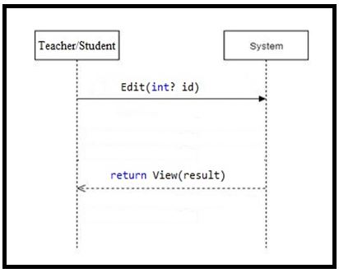

**2.6.2.2 Failure scenario of ?**

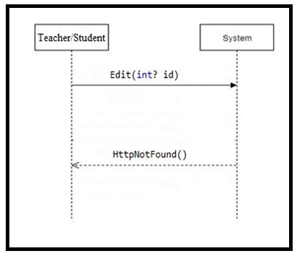

**2.6.3 Payment**

**2.6.3.1 Success scenario**

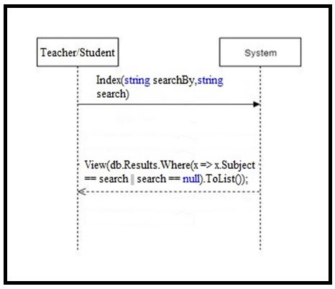

**2.6.3.2 Failure scenario**

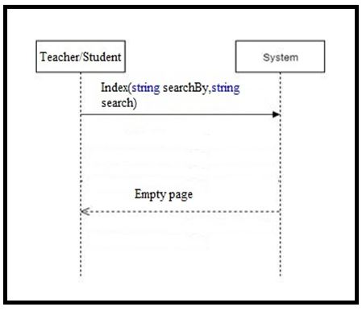

## Domain/Conceptual Model

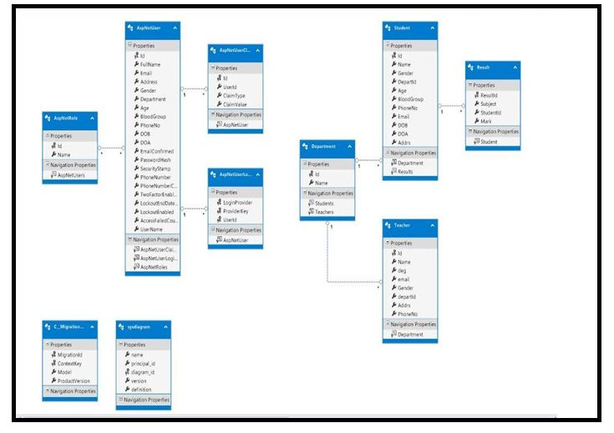

**Figure 2.17 System Domain Model**

## Activity diagram

Activity diagrams are graphical representations of workflows of stepwise activities and actions with support for choice, iteration and concurrency.

In the system workflows starts from the stage when an applications enters by logging to the account. This whole process is shown in the below diagram.

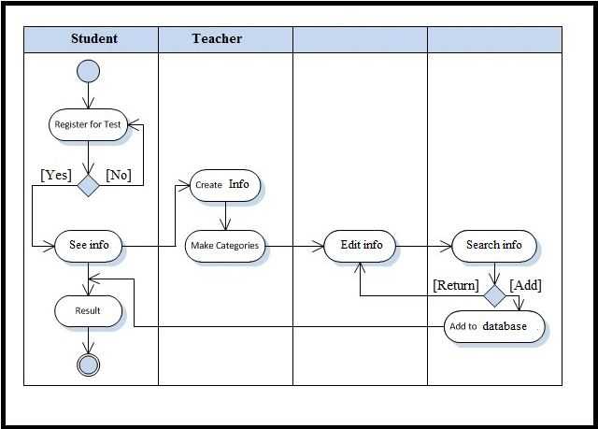

**Figure 2.18 Activity Diagram of the system**

Chapter 3

**System Design**

# System Design

Design is a process that uses the product of analysis to produce a specification for implementing a system. Design is the logical description of how a system will work.

Design emphasizes a conceptual solution that fulfills the requirements, rather than its implementation. For example, a description of a database schema and software objects. Design ideas often exclude low-level or "obvious" details obvious to the intended consumers. Ultimately, designs can be implemented, and the implementation (such as code) expresses the true and complete realized design. The term is best qualified, as in object-oriented design or database design.

## Sequence Diagrams

The UML includes interaction diagrams to illustrate how objects interact via messages. They are used for dynamic object modeling. The term interaction diagram is a generalization of two more specialized UML diagram types:

### Register Account



Figure 3.1 User Register Account

## Class Diagram

Class or structural diagrams define the basic building blocks of a model. They are used for static object modeling, describing what attributes and behavior it has rather than detailing the methods for achieving operations.



Figure 3.8 Class Diagram of System

## Entity Relationship Diagram

An entity-relationship model is an abstract and conceptual representation of data. Entity-relationship modeling is a database modeling method, used to produce a type of conceptual schema or semantic data model of a system, often a relational database, and its requirements in a top-down fashion. Diagrams created by this process are called Entity-Relationship Diagrams. 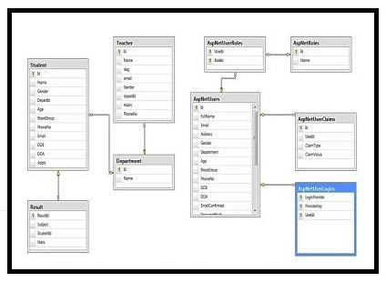

Figure 3.9 Entity Relationship Diagram

Chapter 4

**Implementation**

# Implementation

Implementation (software) perspective describes software implementations in a particular technology (such as C#). In the UP, Implementation means programming and building the system, not deploying it.

In the implementation phase, the developer builds the components either from scratch or by composition given the architecture document from the design phase and the requirement document from the analysis phase. The architecture document should give guidance. Sometimes, this guidance is found in the requirement document. The implementation phase deals with issues of quality, performance and debugging. The end deliverable of implementation phase is the product itself.

## Tools &Technologies

Following are the tools and technologies used in development of this project:

Microsoft Visual Studio 2013

ASP.NET Framework

Microsoft SQL Server 2012

Microsoft Visio

Microsoft Architect

HTML5, CSS, JavaScript, J-query, Bootstrap

## Project Link

https://github.com/shabbir664/StudentPortal-master

Chapter 5

**System Testing**

# System Testing

## Why Software Testing is Essential?

[Software Testing](http://istqbexamcertification.com/what-is-a-software-testing/) is necessary because we all make mistakes. Some of those mistakes are unimportant, but some of them are expensive or dangerous. We need to check  everything and anything we produce because things can always go wrong – [humans make mistakes all the time](http://istqbexamcertification.com/when-do-defects-in-software-testing-arise/).

### Black box testing

Black-box testing is a method of [software testing](https://en.wikipedia.org/wiki/Software_testing) that examines the functionality of an application without peering into its internal structures or workings. This method of test can be applied virtually to every level of software testing: [unit](https://en.wikipedia.org/wiki/Unit_test)**,** [integration](https://en.wikipedia.org/wiki/Integration_testing)**,** [system](https://en.wikipedia.org/wiki/System_testing) and [acceptance](https://en.wikipedia.org/wiki/Acceptance_test)**.** It is sometimes referred to as specification-based testing.

### White box testing

White-box testing (also known as clear box testing, glass box testing, transparent box testing, and structural testing) is a method of testing [software](https://en.wikipedia.org/wiki/Software) that tests internal structures or workings of an application, as opposed to its functionality . In white-box testing an internal perspective of the system, as well as programming skills, are used to design test cases. The tester chooses inputs to exercise paths through the code and determine the expected outputs. This is analogous to testing nodes in a circuit, e.g. [in-circuit testing](https://en.wikipedia.org/wiki/In-circuit_test) (ICT). White-box testing can be applied at the [unit](https://en.wikipedia.org/wiki/Unit_testing)**,** [integration](https://en.wikipedia.org/wiki/Integration_testing) and [system](https://en.wikipedia.org/wiki/System_testing) levels of the [software testing](https://en.wikipedia.org/wiki/Software_testing) process. Although traditional testers tended to think of white-box testing as being done at the unit level, it is used for integration and system testing more frequently today. It can test paths within a unit, paths between units during integration, and between subsystems during a system–level test. Though this method of test design can uncover many errors or problems, it has the potential to miss unimplemented parts of the specification or missing requirements.

## Test Cases

### Test case: Sign up

Project: Project title

Author:

Date:

|  |  |
| --- | --- |
| Test case ID | TC 001 |
| Test case manager |  |
| Functional area | Sign up |
| Test name | Sign up with empty fields. |
| Objective | The purpose of this test case is to verify that none of the fields remain empty when a user signs up to create his account. |
| Pre-requisite | The application is running and displaying sign up form. |
| Steps to perform | 1. Submit the form with a number of empty fields.  2. Click the sign up button. |
| Expected result | Error message is displayed indicating empty fields. |
| Test result | 🗹 Pass 🞎 Fail |

Chapter 6

**Conclusion**

# Conclusion

In this report, an information system’s development has been presented. It was emphasized

on the basic steps, consequently taken during the project’s development course as a particular attention was turned to the basic operative functions performed upon the data into the database.

From our project, Student and Teacher of our country will get a great benefit from this. At last I will thank our honorable teacher **Md. Alamgir Kabir** to help us in making this project.

## Good Features of the System

This system will be used by teachers and students of varsities. Teachers can login, register, add info and student can also login, register and see their info from anywhere

## Limitations of the System

We could not able to provide all kind of features which are given in modern student portal symtem.

## Future Enhancements

We will try to make some features in our next version. For example here I show only the

GPA but not show the total result of a semester. In my project in the student and teacher profile have not any picture next version I will try to implement this things. In next version I will include the Transaction history, Students attendance information, class test and other

activity etc.

**Chapter 7**

**References:**

https://docs.microsoft.com/en-us/

http://stackoverflow.com/

http://studentportal.diu.edu.bd/loginhttps://www.youtube.com/user/kudvenkat

www.capterra.com

www.getapp.com